The Tribe Has Spoken
The jury on the television showSurvivor is made up of eliminated contestants on the reality series. This may be the most literal example of a jury of your peers.
Survivor started in Sweden and now has versions in 13 countries around the world, including South Africa, the Philippines, and, of course, the United States.
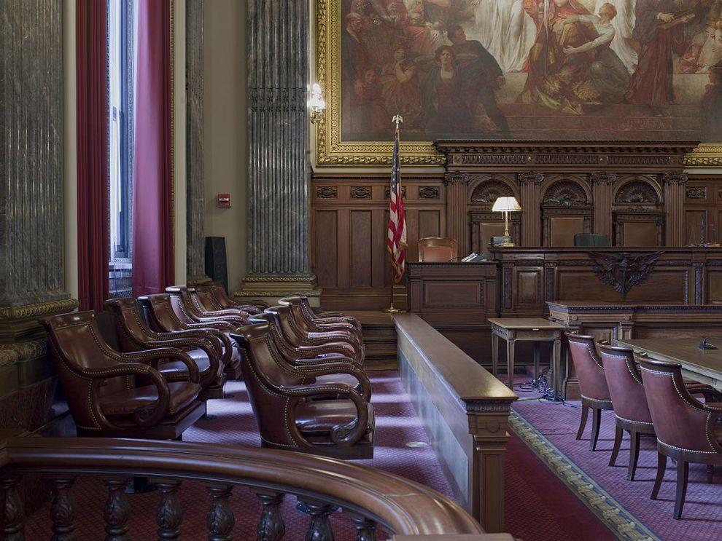
A jury is a group of people selected to determine specific facts, according to specific evidence. This can be a legal jury, a group of people who swear to determine the facts of a court case. A jury can also determine winners in competitions, such as art.
Many countries use juries as part of their legal system. In most countries that use juries, they are triers of fact, meaning juries determine the facts present in the case. Judges, on the other hand, are triers of law, meaning they determine the legal issues in the case.
Legal Juries in the U.S.
In the United States, a jury begins with a call for jury duty. To be eligible for jury duty, one must be a legalcitizen of the U.S., be at least 18 years old, have no record of felony crime charges, be able to speak English, and live in the jurisdiction, or area in which the jury is called, for at least a year. Most citizens are called for jury duty at least once in their lives. Jury duty is not optional.
Jury selection eliminates most potential jurors. Part of the reason is that most legal disputes are settled without trials.
Jurors selected for trials are questioned by attorneys and approved or rejected. Potential jurors who have a conflict of interest in a case are not allowed to be on that cases jury. A conflict of interest is when a person has knowledge of the case, such as knowing one of the people involved, that may unfairly influence their fact-finding abilities. In states that have the death penalty, such as Texas and South Dakota, jurors in death-penalty cases must be death-qualified. A death-qualified jury is not opposed to the death penalty.
There are two major types of legal juries in the U.S.: agrand jury and a trial jury. A grand jury is made up of between 12 and 23 people who decide if there is enoughevidence to proceed with a full trial. Grand juries do not decide guilt or innocence, just if there should be a trial at all. A grand jury is used in about half of the states in the U.S.
A trial jury, also known as a petit jury, is the most familiar type of jury to most Americans. The U.S. uses juries for most types of trials, from murder to bank robbery. Some other countries use juries less regularly. Most countries do not use juries at all.
The number of jurors used in jury trials varies. In the U.S., juries are made up of 12 jurors. In Brazil, its seven. In Norway, its 10.
Juries can decide the facts in criminal and civil cases.Criminal cases are those where the government (thestate, county, or nation) is prosecuting, or carrying out the legal action. Defendants in criminal cases are accused of committing crimes not allowed by the government, such as murder or robbery. Civil cases are those where one individual or organization is prosecuting another. Examples of civil cases a jury might hear areproperty and contract disputes. Civil cases usually involve money, while criminal cases can involve the possibility of imprisonment.
After hearing evidence from the prosecution and the defense, juries decide the facts. They are sometimes given specific rules, called jury instructions, from the judge in the trial. Jurors take notes during the trial, listen to jury instructions, then discuss the case with each other. These discussions are called jury deliberations. Jury deliberations are led by the leader of the jury, called a jury foreman.
Juries return their verdict, or decision, to the judge. In some jurisdictions, the verdict must be unanimous, meaning all jurors must agree. In other jurisdictions, the verdict must simply reflect the majority. A jury that is unable to reach a verdict is called a hung jury. At this point, the judge declares a mistrial. The case may or may not be retried.
If a jury believes a law is unjust or unfair, it can reject that law. This controversial practice is called jury nullification. This happens rarely, and usually involves the jury allowing the accused person to be excused of the crime despite evidence of guilt. Juries that practice jury nullification believe rejecting the unfair law is more important than punishing the person who broke the unfair law. Judges do not support jury nullification. Jurors can sometimes be expelled from juries for considering the law itself, instead of the facts of the specific case.
In other countries, such as the United Kingdom, a similar situation exists. Its called jury equity and is tolerated a little more than it is in the U.S.
Legal Juries
There are three major types of legal systems that use juries: common law, civil law, and religious law. There is wide variation within each type of legal system.
The U.S. uses a common law system, meaning legal decisions are made through a series of courts. The U.S. uses juries for both criminal and civil trials. Canada also uses a common law system, and uses juries for the most serious types of criminal trials, such as murder. India uses a common law system, but outlawed the use of juries in all trials in 1960.
Most countries use civil law, in which legal decisions are made based on a collected series of rules, not judges or court cases. Russia has a civil law system that rarely uses juries for either criminal or civil trials. Indonesia has a civil law system that never uses juries.
Few countries use religious law as a national legal system. It is most common in the Middle East, where countries look to the holy book of Islam, the Quran, for guidance. This law, called Shariah and fiqh, allows for juries. Iran uses juries for some criminal cases.
Other Types of Juries
Less formal juries exist all over the world. These juries are often used for judging goods and services. Local groups can select juries to judge the quality of local services, such as auto repair or hairdressing.
Juried art shows can be very prestigious. The Venice Biennale, held every two years in Venice, Italy, was established in 1895. It is probably the most famous juried art show in the world. The annual Cannes Film Festivals awards are decided by an international jury of filmdirectors, writers, and actors who gather in Cannes, France, to judge the competition.
Blue-ribbon juries are a unique type of non-trial jury. Blue-ribbon juries are often selected by the government, often in cooperation with nonprofit organizations. Blue-ribbon juries study a specific problem, such as air pollution or urban crime, and make recommendations. Jurors are usually experts in the area being studied, such as university professors or business leaders.

International Criminal Court
The International Criminal Court, in The Hague, Netherlands, tries people accused of war crimes, crimes against humanity, and genocide. The International Criminal Court does not use juries.

